**Theta Notation**

This article will discuss Big - Theta notations represented by a Greek letter (Θ).

**Definition:** Let g and f be the function from the set of natural numbers to itself. The function f is said to be Θ(g), if there are constants c1, c2 > 0 and a natural number n0 such that c1* g(n) ≤ f(n) ≤ c2* g(n) for all n ≥ n0

**Mathematical Representation:**

Θ (g(n)) = {f(n): there exist positive constants c1, c2 and n0 such that 0 ≤ c1* g(n) ≤ f(n) ≤ c2* g(n) for all n ≥ n0}  
Note: Θ(g) is a set

The above definition means, if f(n) is theta of g(n), then the value f(n) is always between c1 * g(n) and c2 * g(n) for large values of n (n ≥ n0). The definition of theta also requires that f(n) must be non-negative for values of n greater than n0.

**Graphical Representation:**

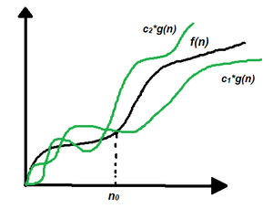Graphical Representation

In simple language, Big - Theta(Θ) notation specifies asymptotic bounds (both upper and lower) for a function f(n) and provides the average time complexity of an algorithm.

Follow the steps below to find the average time complexity of any program:

1. Break the program into smaller segments.
2. Find all types and number of inputs and calculate the number of operations they take to be executed. Make sure that the input cases are equally distributed.
3. Find the sum of all the calculated values and divide the sum by the total number of inputs let say the function of n obtained is g(n) after removing all the constants, then in Θ notation its represented as Θ(g(n))

**Example 1:**

 var doLinearSearch = function(array, targetValue)

    {  for (var guess = 0; guess < array.length; guess++)

        {    if (array[guess] === targetValue)

             {        return guess;  // found it!

              }

         }

      return -1;  // didn't find it

   };

Each time the for-loop iterates, it has to do several things-

* compare guess with array.length
* compare array[guess] with targetValue
* possibly return the value of guess
* increment guess.

So the complexity will be theta n.

**Example 2:**Consider an example to find whether a key exists in an array or not using linear search. The idea is to traverse the array and check every element if it is equal to the key or not.

The pseudo-code is as follows:

bool linearSearch(int a[], int n, int key)

{

for (int i = 0; i < n; i++) {

if (a[i] == key)

return true;

}

return false;

}

Below is the implementation of the above approach:

C++Java

// C++ program for the above approach

#include <bits/stdc++.h>

using namespace std;

// Function to find whether a key exists in an

// array or not using linear search

bool linearSearch(int a[], int n, int key)

{

// Traverse the given array, a[]

for (int i = 0; i < n; i++) {

// Check if a[i] is equal to key

if (a[i] == key)

return true;

}

return false;

}

// Driver Code

int main()

{

// Given Input

int arr[] = { 2, 3, 4, 10, 40 };

int x = 10;

int n = sizeof(arr) / sizeof(arr[0]);

// Function Call

if (linearSearch(arr, n, x))

cout << "Element is present in array";

else

cout << "Element is not present in array";

return 0;

}

**Output**

Element is present in array

In a linear search problem, let's assume all the cases are uniformly distributed (including when the key is absent in the array). So, sum all the cases (when the key is present at position 1, 2, 3, ......, n and not present, and divide the sum by n + 1.

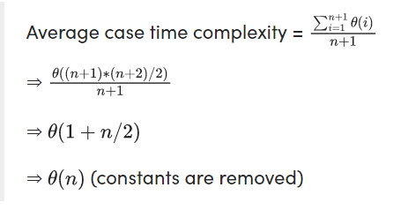

**When to use Big - Θ notation:**Big - Θ analyzes an algorithm with most precise accuracy since while calculating Big - Θ, a uniform distribution of different type and length of inputs are considered, it provides the average time complexity of an algorithm, which is most precise while analyzing, however in practice sometimes it becomes difficult to find the uniformly distributed set of inputs for an algorithm, in that case, Big-O notation is used which represent the asymptotic upper bound of a function f.

Mark as Read